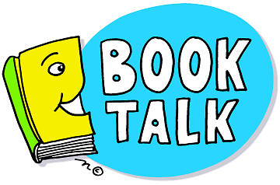
Below you will find a list of possible questions to help with conversations about your child’s reading. They are not intended to be used every time you read with your child. Use them at your discretion and where they are appropriate. Happy Reading!

Before reading:
- Looking the title, cover, and illustrations/pictures, what do you think will happen in this book?
- What makes you think that?
- What characters do you think might be in the book?
- Do you think there will be a problem in the story?
- What do you already know about the topic of this book?

During reading:
- What has happened in the story so far?
- What do you predict will happen next? What makes you think that?
- Why do you think the character did ________?
- What would you have done if you were the character?
- When you read, what pictures do you see in your head? How did you imagine it looked?
- What are you wondering or noticing as you read?
- How do you think the story will end?

After reading:
- Were your predictions correct? If not, what actually happened?
- If there was a problem, did it get solved? How did the character try to solve the problem?
- Did any of the characters change throughout the story? Who changed, how did they change?
- Why do you think the author wrote this?
- What was your favorite part? Why?
- Can you retell the story in sequence (use sequence words: first, second, then, last)?
- Does this book remind you of another book you know? Does it remind you of something you have done?

Follow-up Suggestions:
Have your student draw their favorite part of the story, have them act out a scene from the book, create a commercial for a book, or write a postcard to the author. Anything goes as long as they are thinking about their reading!

6/16

Below you will find a list of possible questions to help with conversations about your child’s reading. They are not intended to be used every time you read with your child. Use them at your discretion and where they are appropriate. Happy Reading!

Before reading:
- Looking the title, cover, and illustrations/pictures, what do you think will happen in this book?
- What makes you think that?
- What characters do you think might be in the book?
- Do you think there will be a problem in the story?
- What do you already know about the topic of this book?

During reading:
- What has happened in the story so far?
- What do you predict will happen next? What makes you think that?
- Why do you think the character did ________?
- What would you have done if you were the character?
- When you read, what pictures do you see in your head? How did you imagine it looked?
- What are you wondering or noticing as you read?
- How do you think the story will end?

After reading:
- Were your predictions correct? If not, what actually happened?
- If there was a problem, did it get solved? How did the character try to solve the problem?
- Did any of the characters change throughout the story? Who changed, how did they change?
- Why do you think the author wrote this?
- What was your favorite part? Why?
- Can you retell the story in sequence (use sequence words: first, second, then, last)?
- Does this book remind you of another book you know? Does it remind you of something you have done?

Follow-up Suggestions:
Have your student draw their favorite part of the story, have them act out a scene from the book, create a commercial for a book, or write a postcard to the author. Anything goes as long as they are thinking about their reading!

6/16

